**Biological Buffers**

* Biological fluids (like blood) have characteristic pH values.
* Many reactions that occur in the body are acid-base reactions that can change the pH of blood.
* Buffers provide a way for the body to maintain the pH in the correct range.

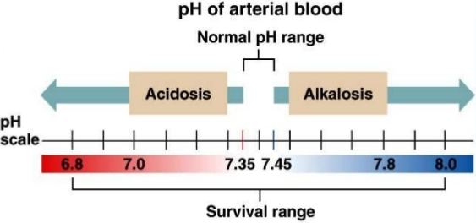**Carbonate Buffers in Blood**

* Blood needs to maintained between the small pH range of 7.35-7.45
* If the pH drops below this range, you will display symptoms of a condition called acidosis.
* If the pH rises above this range, you will show symptoms of a condition called alkalosis
* If the pH changes to far from the ideal range death is possible.
* The following carbonic acid - hydrogen carbonate buffer system helps maintain the correct pH in blood.



(acid) (conjugate base)

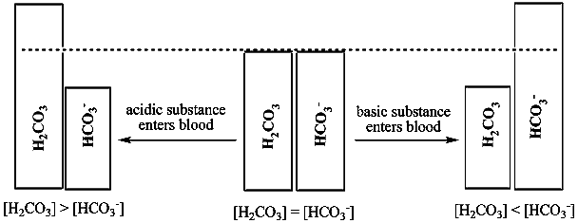



*Definition (buffer)*

To lessen or moderate the impact of (something).

**Phosphate Buffer System in Cells**

* Fluids inside all cells need to be maintained at a specific pH
* The dihydrogen phosphate – phosphate buffer system helps maintain pH in cells.

H2PO4-(aq) + H2O(l) 🡨🡪 H3O+(aq) + HPO42-(aq)

(acid) (conjugate base)